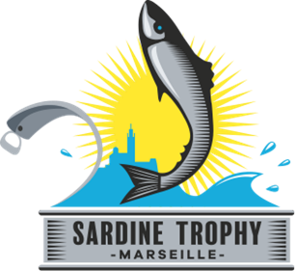
Sardine Trophy
Application form

Contact information
First name/Last name :
Function within the compagny :
Email :
Phone :

- Your start-up presentation

Compagny name
Brief history of the compagny
Object/purpose of the compagny

(200 words max.)
Nature of the innovation carried by the compagny :

Field/Business area/Product and customer target

2) Biography of the founder(s)

Photo | Name, last name, age
Describe your path and profile
Présent what led you to create this start-up

You can add any complementary document presenting the compagny (20 Mo max - pdf, ppt, docx, doc)
3) Your project
Desbribe the degree of progress of the product or service under development (check the corresponding box) :
- Study : level of design advancement and defined methodology
- Prototype : materialized product with or without test experience (specify if you have a product to show at the Sardine Trophy)
- Product in commercialization phase and market positioning
Specify (500 mots max) :

Present a simplified business plan over 3 years (2 pages maximum)

4) Your expectations by participating in the Sardine Trophy
- What are your expectations for this contest ? (250 words max.)

- What are your needs for the development of your project ? Check the corresponding boxes
- Resources and skills : you need to finalize your entrance into the market and need a multi-skills and supervised help
- Promotion and visibility : you want a broad communication to promote your project and increase your visibility in order to grow
- Relations et Business : you want to develop your network and boost meetings and business opportunities

- How the support services provided by the Sardine Trophy partners will be particularly useful ? Develop your needs (300 words max.)

5) Your short video presentation
Make a short video presentation of your project in 1 minute 30 in which you present the start-up project and its motivations to compete in the Sardine Trophy.

