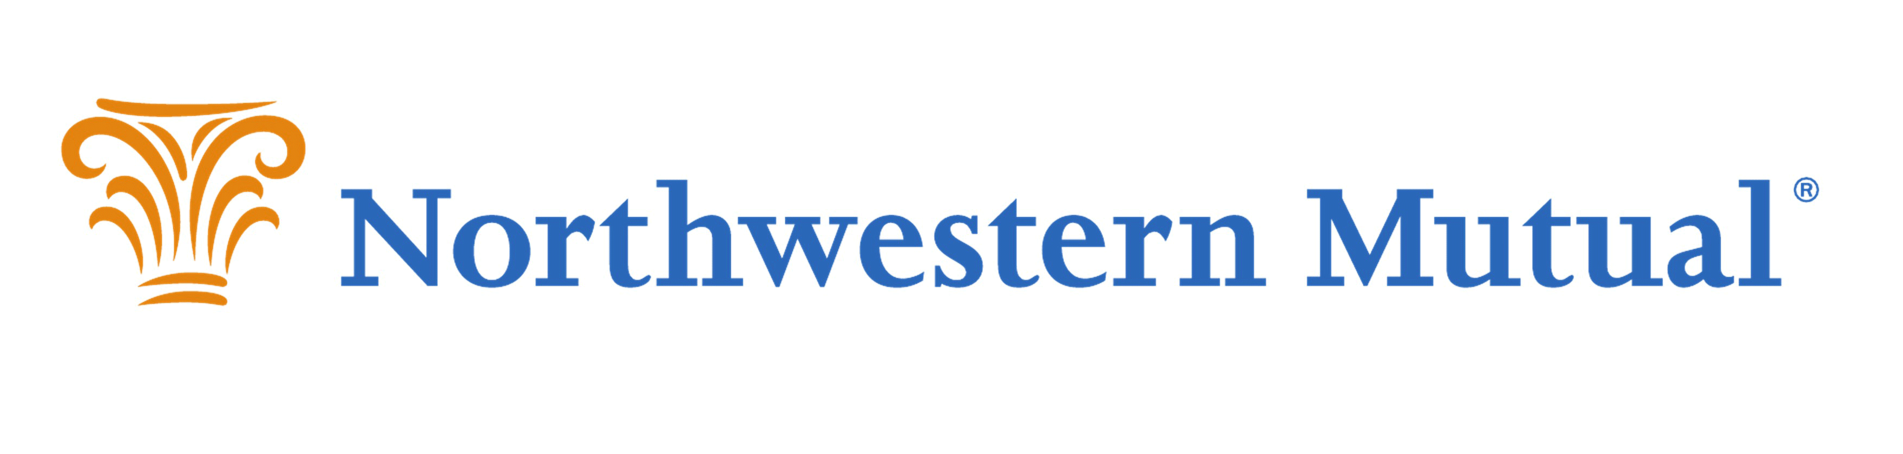
2020 Drive Out Childhood Cancer Golf Outing
Pleasant View Golf Course
Thursday, June 11th, 2020
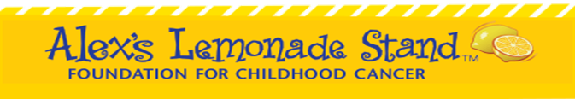
Our Vision
Letting children be children. Allowing their innocence, curiosity and joy be a driving force in our mission.
Our Mission
To inspire people to contribute their time, talent, or resources to have an impact on children affected by cancer.

About Alex’s Lemonade Stand:
Alex’s Lemonade Stand Foundation (ALSF) is a national childhood cancer foundation dedicated to raising funds for research into new treatments and cures for all children battling cancer. To date they have raised over $100 million in the fight against childhood cancer and have funded over 475 research projects.
Alex’s Lemonade Stand Foundation is a national 501(c) non-profit organization (Tax ID#56-2496146) with the primary focus to find a cure for all childhood cancers.
For More Event Information Visit: http://drivingoutchildhoodcancer.com
Please take a moment to review the enclosed Sponsorship Opportunities and consider one of the support levels. With your gift, you can join us in our endeavor to support Alex’s Lemonade Stand Foundation.

Kosnick Financial Group/Northwestern Mutual Goal
Donate $1,500,000 to youth cancer charities by 2028.

Big Thanks to Our 2019 Sponsors

Cresa Zimbrick
Olson Toon Landscaping HotelRED
Firehouse Subs Balance and Believe
Northwestern Mutual Tom Gullickson, Inc
Superior Water Miller & Sons
James Pope Pharo Marine
Artis Reit APPS
Lerdahl Business Interiors Dogtopia
CG Schmidt, Inc KMA Bodilly
Von Briesen & Roper Dahmen’s At Hawks
KMA Bodilly EMSI
Chalmers Jewelers Beat the Badger
Steven Construction Tito's Vodka
Volvo Chalmers Jewelers
Oak Bank Verona Safety
Frank Production Fine Line Attire
Aberdean Consulting Steven Construction
Karben4

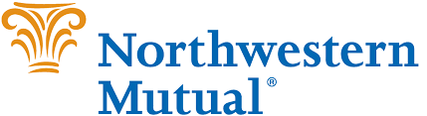
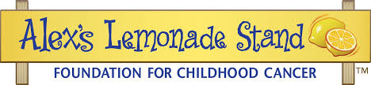

2020 Drive Out Childhood Cancer Golf Outing
Pleasant View Golf Course
June 11th, 2020

*Sponsor to provide promotional materials, logo, and signed logo release. Deadlines apply.

PLEASE CHECK THE APPROPRIATE SPONSORSHIP LEVEL
 |  | Co-Presenting Sponsor | $10,000
 |  | Eagle Sponsor | $8,000
 |  | Hole In One Sponsor | $5,000
 |  | Birdie Sponsor | $2,500
 |  | Par Sponsor | $1,500
 |  | Hole Sponsor | $500
Please accept our official sponsorship; will submit full payment no later than May 1, 2019
Sponsor Information
Business Name
Contact Name
City/State/Zip
Phone Email
Credit Card Information
Cardholder Name Billing Zip Code
Card # Exp. Date CVV Code

Please accept our official sponsorship; will submit full payment no later than May 1, 2019

Check is enclosed, made payable to: Kosnick Financial Group FBO Alex’s Lemonade

MAIL Checks to:
Kosnick Financial Group FBO Alex’s Lemonade Attention: Hayley Peterson
1600 Aspen Commons #800, Middleton, WI 53562

Alex’s Lemonade Stand Foundation For Childhood Cancer Tax ID#56-2496146.

Questions Contact: Olivia Williams olivia.f.williams@nm.com (608) 662-3879
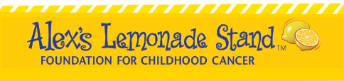

LOGO RELEASE – TO BE COMPLETED BY COMPANY/ORGANIZATION

1.) Company/Organization Name:

2.) Contact Name:

3.) Contact Number:

4.) Expiration Date of permission: If no expiration, enter “None”.

5.) Please describe any restrictions or stipulations with regards to using your logo:

Signature:

Date:

