Winning Your Traffic Crash Injury Claim In Illinois
Guidelines For Success With Your Illinois Vehicle Accident Claim

Scott Blumenshine, Attorney at Law

Copyright © 2016 by Scott Blumenshine
All rights reserved. No part of this book may be used or reproduced in any manner whatsoever without written permission of the author.

ISBN: s

Designed and Published by:
Speakeasy Publications
73-03 Bell Blvd #10
Oakland Gardens, N.Y. 11364
www.SpeakeasyMarketingInc.com
888-225-8594
DISCLAIMER
This publication is intended to be informational only. No personal legal advice is given, and no attorney-client relationship is created by reading this material. If you have a legal claim, you may need to consult with and retain professional legal counsel to get your questions answered and action taken if needed.

Scott A. Blumenshine
Chicago, IL
(312) 263-1000
sbshine@mbpersonalinjurylaw.com
www.mbpersonalinjurylaw.com
Client Testimonials
“I couldn’t have made a better selection of an attorney to represent me. Scott Blumenshine really took matters into his hands and always made me feel my case was truly important. Genuine, respectful service. I am very happy and glad that a friend recommended this law firm to me. Thank you for everything Scott.” - H.R.
……………………………………………………………………….
“I am very pleased with the services I received from the firm. I always knew that Scott was looking out for me and my best interests with his tireless pursuit of justice. Thank you, Scott and team. I will always remember how you made it right for me. You keep your promises.” –B.W.
……………………………………………………………………….
“I have never been involved in a lawsuit and was hesitant, but could not be more pleased that I get the medical treatment for my injuries, as well as a settlement for all the other expenses. Highly recommended.” -K.T.
……………………………………………………………………….
I just wanted to say thank you very much for all your efforts and determination that you had Scott. Thank you for not giving up on me when everyone else did. I could tell that you had compassion for my case, you saw how my leg injury really affected me. And for that, I thank you. Thank You for putting yourself in my shoes and realizing how bad this thing really was. The hard work you and your team did will never be forgotten. Thank you from me and my family.”
- M.B.
Table of Contents
Traffic Crash Injuries and The Insurance Claim
Attorney Introduction
Handling An Auto Accident Claim
Options Available For Obtaining Compensation
Time Limits For Bringing An Auto Accident Lawsuit In Illinois
Car Insurance Law Requirement In Illinois
Role Of Police In An Auto Accident
Role Of Insurance In An Auto Accident
Viability of An Auto Accident Claim In Illinois
Importance Of Medical Attention After An Accident
Payment of Medical Bills In An Auto-Accident Case
Can An Attorney Help Negotiate Down Medical Bills?
Top Misconceptions Regarding Auto-Accident Claims
How Do I Get My Car Repaired After An Auto-Accident?

Commercial Vehicle Collisions
Types Of Vehicles Involved In Commercial Vehicle Accidents
Common Causes Of Commercial Vehicle Accidents
Liability For An Accident Involving a Commercial Vehicle
Difference Between Commercial And Passenger Vehicle Accidents
The Challenges People Face In Commercial Vehicle Accident Cases
What Happens If My Commercial Vehicle Accident Claim Is Denied?
Uninsured, Hit and Run and Underinsured Motorist Claims
What If I’m Involved In An Auto Accident With An Uninsured Motorist?
Does Illinois Require Uninsured Motorist Coverage?
Is It Advisable To Sue An Uninsured Person?
Common Misconceptions Regarding Uninsured Motorists
How Are Hit And Run Accidents Handled In The State Of Illinois?
Responsibility For A Hit And Run Accident In Illinois
Importance Of Retaining An Attorney For A Hit And Run Claim
Scott Blumenshine Handles Hit And Run / Uninsured Motorist Claims

Attorney Introduction
Scott Blumenshine’s professional mission is to obtain prompt and fair payment of his client’s claim. Personalized, strategic, compassionate service helps to achieve that goal.
He believes in the duty from Proverbs 31:8, “Speak up for those who cannot speak for themselves, ensure justice for those who are being crushed.”
He has recovered millions of dollars in compensation for clients through settlement, mediation, arbitration and trial. He listens to your story and your concerns and answers your questions. He and his team explain the claim process to you. They then work to achieve a fair and timely result.
Mr. Blumenshine is invested in improving the legal system for the public. He writes on current legal issues and addresses fellow lawyers at continuing legal education seminars. He authored Illinois Insurance Code amendments which increased penalties against insurers
for Insurer Bad Faith Delay and Denial. Other legislation he authored increased the limit for binding arbitration awards on Uninsured and Underinsured motorist claims.
Mr. Blumenshine has been a voice in the legal system regarding significant public safety dangers. He has been interviewed and provided commentary on TV for many high profile cases. Additionally, he has been quoted in articles regarding Illinois insurance law.

Handling Auto Accident Cases
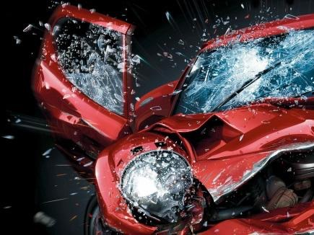
I have represented hundreds and hundreds of people in their injury claims. I’ve been practicing law for 28 years. Every case is different and a challenge. It is a pleasure to meet, represent and work with every single client.
“Handling” a claim means doing everything required from beginning to end. The beginning of a potential case is our initial meeting which can be in person, by phone or through email exchanges.
We listen to your story and ask you what you need. We gather evidence about the incident including incident reports, video, photographs and witness statements. We often visit and photograph the scene, vehicles and injuries. We then gather medical records and bills and prepare and deliver a settlement demand to the other party. Our demand is done with your agreement. We attempt to reach a prompt and fair settlement with the insurance company. If the insurer is not reasonable, then we file a lawsuit in court.
A lawsuit involves ongoing actions including court appearances, taking sworn testimony, collecting records, drafting and filing legal documents, and strategizing on how to succeed with your case.
We also resolve cases through arbitration, pre-trial settlement conferences with judges, mediations, and, if necessary, jury trials and appeals. Our team handles your case until it is resolved.
Is an At-Fault Driver Financially Responsible for All the Damages in an Auto-Accident?
Yes. A negligent driver is responsible to compensate an injured person for all their injuries. The injured person is entitled to recover what the law calls “damages.”
Damages are compensation for your injuries. They are intended to make you “whole” or to balance the scale of justice. Damages include financial losses such as medical expenses and lost income as well as non-financial losses such as pain, suffering, disability and disfigurement. Damages are all the consequences that result from being injured. Pain is the physical symptom of your injury - a broken bone or torn ligament will cause pain. To be free from pain is valuable. To suffer pain is costly.
Suffering is the mental anguish that comes with the experience of your physical pain.
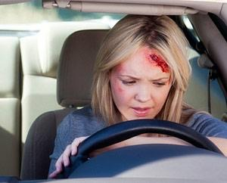
Disability is the inability to function like you did before the accident. You do not need to be bedridden and unable to move to have “disability.” You can be partially disabled. Examples of disability are weakness or limited range of motion in your back. Other examples of disability would be headaches that limit your concentration, or stiffness in your neck that hinders your ability to do computer work for long periods of time.
Disfigurement is a visible physical injury such as scarring or bruising.
One way to think about damages is the phrase “Harms and Losses.” If you’ve been seriously injured, you’ll have harms and losses. The driver who causes an accident is responsible for compensating you for those harms and losses.

Options For People Injured in a Vehicle Accident
The options for someone seeking compensation from an at-fault driver are:
1) Simply do nothing and have their health insurance or their auto medical insurance pay their bills,
2) Make a claim against the other driver’s insurance on their own and see what happens.
or
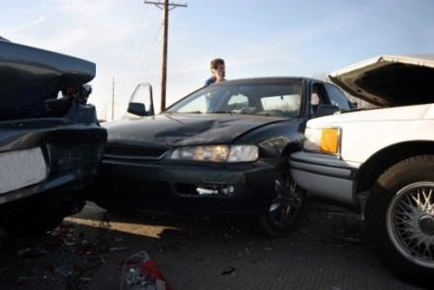
3) Get an effective attorney on their side.
My experience is that insurance companies are so good at delaying and denying claims; An injured person is at a disadvantage when they try to handle a claim on their own. Insurers have billions of dollars, thousands of staff, and the incentive to drag the process out. If insurance company marketing was true, insurers would quickly
and fairly pay everyone what is due. That is not what happens for most valid personal injury claims. Unfortunately, you do not have unlimited time and resources to match insurance company resources.
To be represented by an experienced and capable attorney is necessary if you have serious injury. The legal system has extensive and complicated rules and procedures. A good attorney knows court rules and procedures and also has the savvy to effectively present your claim. A layperson could find and read the rules and procedures somewhere online. But to put the case in motion and keep it in motion is difficult. And to understand all that you are entitled to based on the specific issues of your claim and to successfully resolve it on your own is extremely difficult.
The claims process typically has two stages. The first part is the demand for settlement. Successful negotiations may or may not happen when this demand is first made. If settlement isn’t reached, then the second stage is filing a lawsuit in court. A lawsuit raises the stakes. It requires that specific rules are followed and detailed procedures are done properly and timely.
We often receive calls from people who have attempted to handle their claim or lawsuit on their own, but found themselves unable to properly proceed. We would be glad to help you if you have reached a dead-end handling your claim on your own.
When is a Personal Injury Lawsuit Necessary?
A lawsuit has to be filed if your claim is not settled with quickly and fairly. The unfortunate (semi-secret) truth is that insurance companies usually delay, deny or low ball your claim.
Insurance companies want everyone to think they are warm, fuzzy and generous. Insurers advertise about how wonderful they are: they put you in good hands, and they’re like a good neighbor, and they’ll take care of you. However, when a major injury claim is made, they batten down the hatches, they fight and often insult you, they don’t pay on-time, and they don’t always want to pay fairly. We see it every day.
Now, I understand that I only see disputed claims and it is possible that sometimes insurance companies do pay some smaller cases in a way that satisfies the people affected. The vast majority of cases I have handled, however, involve insurance company delay and denial. When the insurance company does not offer a fair settlement offer, then a lawsuit must be filed.

Time Limits for Filing an Auto Accident Lawsuit in Illinois
Two years is the standard deadline to file a lawsuit. The time limit is called the “statute of limitations.” If a lawsuit is not filed within two years of the incident the right to file suit is lost. There are some exceptions: for example, a child under the age of 18 is not considered an adult with rights that are triggered until they reach 18. Someone who is mentally or emotionally disabled may be considered legally incompetent. Lawsuits against government entities often must be brought within one year. All cases are different, so customized legal advice is recommended.
Do Comparative Fault Rules Apply for Auto-Accidents in Illinois?
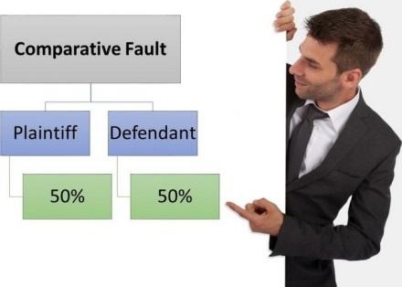
Yes. There are comparative fault rules in Illinois. Comparative fault (also known as contributory negligence) is based on the idea that there may be more than one cause of a crash. For example, in a rear-end collision, almost without exception, the driver who rear-ends someone is 100% at fault. However, in a collision at an intersection, both sides may claim they had the right of way. If the other driver blew a stop sign, but you were driving and were speeding, perhaps you were partially at fault.
Comparative fault is an important principle. It can reduce your recovery by the percentage that you were at fault. If your injury is worth $100,000 but you were 20% at fault your recovery would be $80,000. There is no scientific method for determining percentage of fault; it’s based on the facts. Thus, your ability to testify in a clear and persuasive manner about what happened will affect how a judge or jury views who is at fault and at what percentage. A capable attorney can help you explain your role in an accident in the most positive light and perhaps discredit or counter the other party’s arguments based on the facts.

Car Insurance Law Requirement
in Illinois
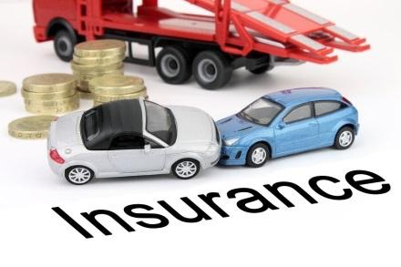
Drivers in Illinois must have at least $25,000 in liability insurance coverage. This is a pitifully low amount. The state politicians have been swayed by insurance company arguments that with higher mandatory minimum limits, insurance would be unaffordable and there would be many more uninsured drivers.
The law requires drivers to have insurance. In my experience, many people disobey the law and drive uninsured. For this reason, it is critically important for you to have adequate uninsured and underinsured motorist coverage. By “adequate,” I mean at least $100,000 and ideally $1,000,000 for you and your family.
Many people drive off the car lot with insurance and then fail to pay their next monthly premium. They are then “uninsured,” which is why uninsured and underinsured motorist coverage is so essential for you and your family. You have to protect yourself, your family and your passengers. If there is one thing you can take away from this book, please do this - call your insurer and make sure you have at least $100,000 in uninsured and underinsured motorist coverage. Look into the nominal cost to move it to at least $100,000. You will be very glad you did so if you ever need it. The cost is not much relative to the amount of the coverage.
Steps to Take in Filing an Auto-Accident Lawsuit
The first thing you should do after an auto accident is to get medical treatment. Whether you go to the emergency room, an urgent care center, or your doctor, you must get medical care. You may just feel a little twinge, or discomfort, but small symptoms can be a sign of something more serious. So get examined. Follow your doctor’s instructions. Take care of yourself.
The second thing to do is to document your claim. Think like an investigator or a police detective and gather every scrap of information you can: scene photos, vehicle photos; witness information; notes of the circumstances, such as traffic conditions or something the other driver said or did at the scene. Write down your own recollection of what happened in detail as soon as possible while the events are fresh in your mind.
Do not sign anything. Do not give any statements to the other driver’s insurance company.
Shortly after the incident, you should take time to find and speak with a qualified, trustworthy attorney. The consultation must be free and without obligation. This initial consultation should be a valuable experience.
Do not speak with “Ambulance Chasers.” They are the attorneys or their “investigators” who illegally swoop down on the scene or the emergency room and pester you. The law prohibits this conduct. An ambulance chaser is violating the law before they even represent you! Imagine what they might do with your case if you decide to have them represent you.
Ask a trusted family member, friend, c0-worker or professional for a recommendation. Search the internet for an attorney who is competent, trustworthy, has great results and has good references from former clients. A phone call with an attorney should cost you nothing but your time and will be well worth it, even if you decide to handle your case yourself.

Role of Police in an Auto Accident
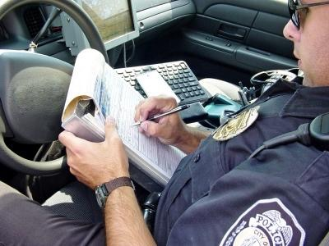
The police should be on the scene of an accident. Don’t leave the scene without having a police officer come and take a report, no matter how minor the collision appears to be. Some police departments will say they don’t come to the scene unless there is a serious injury. If this is the case, go to the police station and file an accident report in person because a police report is critical to protecting your rights.
If you’re carried away from the scene by ambulance and taken to the emergency room, contact the police afterwards. Insurance companies like paper, and a police report is documentation that can help you.
If I am Cited by the Police, Will My Auto Accident Compensation Claim Be Doomed?
No, your case won’t be doomed if a police officer opines the collision was your fault and get a ticket. The facts and the law are what count. Opinions, speculation or guesses by other people are not admissible evidence. A police officer who did not witness the collision cannot prove that you are at fault without the facts to support his or her conclusion. So do not sweat a ticket and talk to an attorney before the court date.
Police officers are rarely witnesses to the incident. They are usually told after the fact by the parties or the witnesses what happened. There are always two sides to a story. If you know you’re not at fault and you didn’t cause the collision, refuse to compromise. The insurance company may deny your claim, but experienced and capable legal counsel can help you fight that denial.

Role of Insurance in an Auto Accident
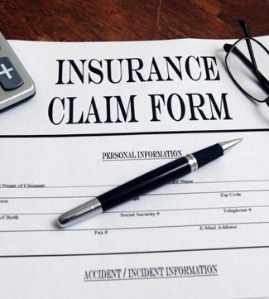
Insurance is 99.99% of the time the source of any payments after a car crash. You should always notify your insurer and the other driver’s insurer of your injuries. You may be wary of making a claim on your insurance for fear of increased premiums or cancelled coverage. However, notifying your insurance company about an accident is not the same as making a claim. If the other driver is at fault and his or insurer steps up and pays for the property damage and your injuries, you do not need to make a claim against your own insurance policy.
The reason to notify your insurance company is so that you don’t lose any rights. Almost all insurance policies say that you have to notify your insurance company of a potential claim in a timely manner.
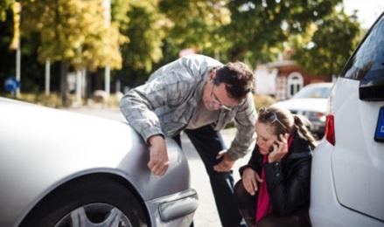
For example, if you’re in a car accident and the other driver is at fault and uninsured, if you don’t tell your insurance company about your injuries and medical bills until many months after the incident, your claim could be denied for your delay in notification.
You may believe that the other driver’s insurance will pay. After all, that’s what the commercials all suggest. If the other insurer does not pay and you then turn to your insurer for payment, your insurance company can say you failed to notify them in a timely basis, you deprived them of the right to investigate, and they can then deny your claim.
As for the other driver’s insurance company, notify them immediately. Again, notifying an insurer is different than making a formal claim. So, before you give a statement or sign any releases or authorizations, please get a free attorney consultation. The consult should be free, with no obligation and is something I strongly recommend.
I have handled many, many cases in which people unsuccessfully tried to settle cases themselves. They often hurt their case by giving statements or signing authorizations. Be very careful about what information you provide to the other driver’s insurance company. The adjuster will sound nice and friendly but - Be Careful – their job is to pay you little or no money and to delay the process.
What to do if the Other Party’s Insurance Company Contacts me?
If the other driver’s insurance company contacts you, it is okay to verify your identity and that you were injured or had property damage. However, I strongly recommend that you not give any statements or sign any documents. Your statements can be evidence used against you. As you have heard on TV and in movies: “anything you say can and will be used against you.”
You have no obligation to the other party’s insurance company. You may be in pain, in shock, on medication or simply unnerved from the accident when the savvy adjuster contacts you. You are in no condition at that time to deal intelligently with an experienced claims adjuster.
Insurance personnel are trained, experienced and knowledgeable about the process - and you are not. You’re in no position to reasonably deal with them until after you’ve had a chance to recover and be prepared. Therefore, before you speak with the other insurance company, get informed and at least speak with an attorney who knows what they’re doing.
What if the Other Driver’s Insurance Company Denies Liability?
You have two options if the other driver’s insurance company denies liability: one is to just forget about it and give up. The other option is to file a lawsuit. While you can legally file a lawsuit yourself, it’s difficult, if not impossible, to do it properly.
Therefore, the best option if liability is denied is to retain an attorney who is experienced, aggressive and capable. Find an attorney with whom you’re comfortable, who understands what happened to you, who understands your goals, and agrees to pursue a full and fair recovery with you.

Viability of an Auto Accident Injury Claim in Illinois
There are three main elements that make an auto injury case viable.
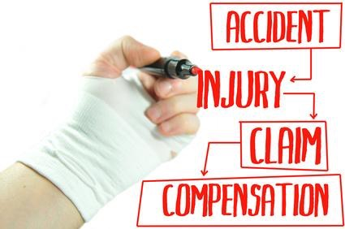
- Liability (fault)
- Damages
- Insurance

The first element is the liability (also called fault or negligence) of the other driver. The easy example of a driver with liability is a rear end collision - yes, that driver is at fault. If the other driver is at fault, and you have a serious injury you may have a viable claim.
Liability is not always clear cut. If you have a collision at an intersection, and you know you had a green light but the other driver says they had a green light, that creates a liability question. If you’re the only witness who says you had a green light and other witnesses say your light was red, you have a problem. But if you have witnesses in your favor who also say you had a green light and the other driver had a red light, liability exists.
The second element of a good case is a significant injury. A significant injury is one that causes you pain and impairs your life for at least several months. Some examples are a head injury, or a back, neck, knee or shoulder injury that requires extensive treatment. Extensive treatment may include therapy, injections, medications and surgery. The injury will keep you from taking care of yourself. You miss work or school. Significant injuries often have lifelong consequences.
An insignificant injury is something minor such as short term whiplash. For example, your neck is sore for a week or two, but you get better and the soreness goes away. It may seem significant to you and your life, but it doesn’t meet the standard of injury of a good case. A jury will not have much sympathy in such a case and the insurance company will thus not offer you much money. You’re fortunate from a heath perspective if you recuperate quickly, but it will be difficult to recover much in the way of legal compensation.
The third element of a viable claim is sufficient insurance. Many drivers have no insurance or low insurance limits. If the person who hits you has little or no insurance, you’ll have an uninsured or underinsured motorist case against your own insurance company.
Sufficient insurance is at least $100,000 for a significant injury. Unfortunately, many people drive around with just the minimum $25,000 in coverage. If your bills are over $25,000, their insurance proceeds will not be enough insurance to pay your claims. A viable case has sufficient insurance coverage. Insurance proceeds can come from the other driver’s liability insurance coverage or your own uninsured or underinsured motorist coverage.
So the three elements of a viable case are the liability of the other driver, a significant injury, and sufficient insurance coverage with the other driver or with your policy.
Timeframe for Resolution for Auto-Accident Cases
Cases typically take a while to settle. What is a while? At least three months and often longer. Some cases can take years. Generally, you should not settle too quickly or early, because you do not know the extent of your injuries until time passes. You must get medical attention. Your body and mind must heal.
Understand that once you settle, you release the other party from any further liability. If you settle too soon, and a year later you still have problems, you’re out of luck. It is important to be patient and not settle too quickly.
If a lawsuit has to be filed, the case could take longer than a year. Cook County courts move cases on a fairly rapid basis. Lawsuits typically go to trial within 18-27 months. Although that seems like a long time, it’s a great improvement from when cases took 5 or more years to get to trial.
We manage the litigation process (to work) in your favor by complying with deadlines and requiring the other side to produce evidence by way of testimony and documents. We then ask the court for the earliest trial date possible. This keeps pressure on insurers who like to delay payment as long as possible.

Importance of Medical Attention After an Accident
Immediate treatment and proper follow up are crucial. I cannot emphasize this enough - if you are hurt, get medical attention.
If you feel fine, and you have no twinges, pains or aches, you don’t have an injury claim and there’s no reason to see a doctor except to confirm that you are ok. However, in my experience, many people who say they initially feel fine, but they have a little headache or dizziness that later turns out to be migraines. You may have had a head injury and you feel “okay,” but there could be something going on that could become something serious if not addressed early and properly.
I have seen many people who feel some neck or back soreness. but they don’t get treatment. A few weeks or months later, the pain and limitations invariably become worse and they begin to suffer unnecessarily. They have pain that keeps them from doing normal things like sleeping, taking care of chores, and working. But they didn’t seek medical attention and do not have a record to show the connection to the accident.
Many conditions turn out to be an injury that seemed minor at first, and because they didn’t get early treatment, it became worse. All doctors, chiropractors, orthopedic surgeons and physical therapists recommend early treatment
is preferred. So, if you are fine and you feel nothing, then maybe you are not injured and maybe you don’t need to see a doctor. However, if you feel anything abnormal, or different, or uncomfortable, get treatment as soon as possible.
How do Delayed Medical Complications Figure in an Auto Accident Claim?
If you wait to see a doctor, the insurance company will argue that you were not hurt at the time of the accident and there is no connection between the crash and your medical condition. The insurer will argue that something else happened to you after the accident, like maybe you tripped or you were in another collision that their insured didn’t cause. It’s a guarantee they will make that argument - and it is difficult to overcome. If you don’t see a doctor right away, you are handing the insurance company ammunition to defeat your claim.
Many judges and jurors agree with the argument that late or delayed treatment means no injury or minor injury. We have seen it time and time again in our own cases and in other cases we follow through the jury verdict reports and settlement reports.
While I understand you don’t want to go to the doctor – no one wants to because it’s inconvenient and it’s time-consuming – for your benefit and the benefit of those who rely on you at home or at work, get the treatment you need now.
This is about your injury. If you are hurt, you need to see a specialist who can diagnose and treat your injuries first. The claim process and litigation is secondary to your physical health. My recommendation is that you get immediate medical attention if you’re hurt. You can address the claims process or legal issues the next day or the week after.

Payment of Medical Bills in an Auto-Accident Case
Ultimately the other driver (through their insurance company) should pay for your medical bills. Payment, however, usually isn't made until the case is settled. Insurance companies don’t pay bills as you incur them, they pay at the close of the case. Your case however can go on for a year or more after your treatment. In the meantime, hospitals, doctors and other medical providers want to be paid. Bills should be paid by your health insurance, or your auto insurer who will later be reimbursed by the other driver’s
If the other driver has no insurance, you’ll look to your own uninsured motorist coverage. And if the other driver’s insurance isn’t enough to cover your medical bills, you look to your underinsured motorist coverage. Uninsured and underinsured motorist insurance are very important sources of protection.
Should I Release my Medical Records to the Other Party’s Insurance?
I strongly recommend that you not sign any release of your medical records to the other driver’s insurance adjuster. Although you may be told and believe that the release is only for records related to your treatment from the injury, the release will be broadly worded and you may be authorizing release of confidential, private medical records going back to your childhood. Your signed release may include release of private psychiatric records and other things that you don’t want disclosed to anyone. And, the insurer will use your records against you to argue for reducing your payment or for not paying you at all.
If you do sign a release, it should only be with an attorney recommendation and in the context of a court case in which there is a strict court order prohibiting those records from being released to anyone other than the insurance adjuster for purposes of evaluating your claim.

Can an Attorney Help Negotiate Down Medical Bills?
Yes. Nearly every injury case that we handle includes hospital bills, medical bills and lien claims and in nearly every case we work on your behalf with lien holders to negotiate those medical bills. A “lien” is the legal term for the claim that a medical provider or health insurer has against any settlement proceeds. The claim is enforced by written notice (a “lien”) to an insurance company and an attorney. In nearly every case we work on your behalf with lien holders to negotiate those medical bills. We will contact each lien holder and negotiate the amount they will recover from your personal injury claim recovery. Illinois law has both statutory and case law rules that limit how much a medical provider can receive from a personal injury settlement, so we’re aggressive about getting those liens reduced. If lien holders won’t work with us, we’ll file a motion in court and ask for a court order to reduce the lien claim.
What if I am Disabled and Unable to Work Due to an Auto Accident?
There are two answers to that question.
One is the practical issue: How do you manage your obligations when you are unable to get around and in pain? Hopefully you’re able to get the proper medical and rehabilitation care to get you on the path to healing. Also, if you are lucky, you have family or friends who can tend to your daily needs at home.
The second question is a financial issue. How will you survive financially? Perhaps you have disability insurance through a personal policy or through work, and that may provide an income source while you’re unable to work until the case settles.
If your injury claim involves an injury that happened during the course of employment, you will have a workers’ compensation claim, which means, by law, your employer has to pay a portion of your income while you’re out of work due to the work injury.
If you have neither disability insurance nor workers’ compensation insurance, the next lines of resource are savings, friends, or family. Also, lawsuit loan companies are in the business of providing high interest loans to people that have filed an insurance claim. We don’t necessarily advocate for those loans; if the client decides to apply for one, however, we will cooperate with the lender in order to assist you in your time of need. Note that the interest rates on those loans tend to be high and you will have to repay the full loan and interest regardless of the amount of your settlement.
Is It Ever Beneficial to Keep a Journal of Events Following the Accident?
Yes. No person has a perfect memory. Claims can take a while to resolve and memories can fade. If you are able to record the specifics of how you feel, your experience in dealing with your injuries, your treatment, and other information - note keeping can be helpful to you and your attorney. Examples of useful information would be sleepless nights due to pain, struggles with household chores, or anxiety over income loss.
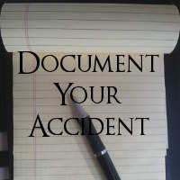
The notes will be marked “personal confidential attorney-client communication” that is used solely for purposes of telling your attorney about your experience. Your attorney can then use the information to support the value of your claim. You should share it only with your attorney in order to keep the legally privileged and confidential nature of the document in place. If you share with others, it may no longer be confidential. It is critical to record your experience before your memory fades.
The Importance of Pictures as Evidence in an Auto-Accident Case
Images can be more powerful and effective than words. So, if you are able, take pictures of the scene. Take pictures of any visible injuries you have, and of any devices such as crutches, wheelchair, or other items provided to you. Get the photos to your attorney.

Top Misconceptions Regarding Auto-Accident Claims
The number one misconception about an injury claim among injured people is that insurance companies will be fair and honest in the way they handle your claim. People are usually shocked, disillusioned and disappointed by the insurance claim experience. We are taught from an early age - if you break it, you must pay for it. Insurers, however, are not governed by morals nor ethics for the most part. The law itself is barely an incentive to do right, at least here in Illinois where the Bad Faith laws are weak. I have fought long and hard to have these laws strengthened. We achieved some increase in the penalties years ago, but the insurance lobby is powerful.
Insurance companies advertise that they cover and protect you. They paint a picture of being a source of warm fuzzies and hugs to make you you feel safe and warm. They advertise this in order make you feel secure so they can sell insurance “promises” and have you pay your premium year in and year out.
When it comes to paying out substantial injury claims, however, insurers are usually confrontational, dismissive, and slow to pay properly and fully. If insurers were fair, why would people need injury attorneys?
The second misconception people have is that they can handle a significant injury case on their own. You are a smart and capable person, but the arena of insurance claims and litigation is filled with all sorts of rules, and not all of them are logically anticipated. You must meet deadlines, follow procedures and implement strategies. The insurance companies have a big leg up on you if you go solo. First of all, they have billions of dollars, claims adjusters, defense attorneys and all sorts of staff to handle these disputes - and you don’t. You are walking into a lion’s den. The reason you can’t handle the case on your own isn’t because you’re not smart or tough enough. It’s because you don’t know the rules and you are outmatched.
A third misconception is that all lawyers are not trustworthy. As in any human arena, there are a few bad apples that spoil the bunch, but in my experience, the vast majority of injury lawyers are trustworthy, honest and there to help you. Certainly the lawyer that you choose should have a long established record of ethical, moral and honest behavior, on top of successful results. The best way to find that lawyer is through references and testimonials.
Unintentional Mistakes People Make that Hurt Their Auto-Accident Claim
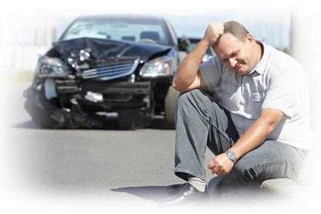
#1 - Not getting the medical care you need. Many times, people wait too long to go to the doctor. Or people go to the emergency room and they don’t follow up. I understand that it’s inconvenient and perhaps scary to go to the doctor, and to therapy, to get injections or more invasive treatment. No one wants to do that, but if you have been injured and intend to make a claim, the only way to document the medical aspect of the claim is to get proper medical care.
So get treatment promptly and follow up fully if you are serious about recovering.
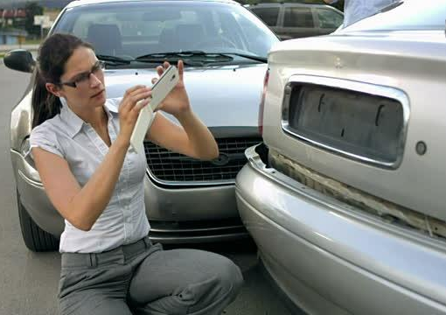
#2 - People can hurt their claim if they don’t document and record how the injury has affected their lives. As lawyers, what we say is not evidence, we can’t testify, or produce photos. We can only use the evidence that is available, including testimony from you and other witnesses like family members and friends, and medical records. If you don’t document and record how the injury has affected your lives, your lawyer can’t fully prove your case.
#3 - Another way that you can hurt your case is to post on Facebook or other social media. If you post items about yourself and insurance companies, defense attorneys can pick up on that. I was in court the other day and an insurance defense attorney said the first thing they do now is to go on Facebook and try to find photos that suggest the person making the claim isn’t really injured.
You probably should stop posting on social media after an injury claim.

How do I get my Car Repaired After an Auto-Accident?
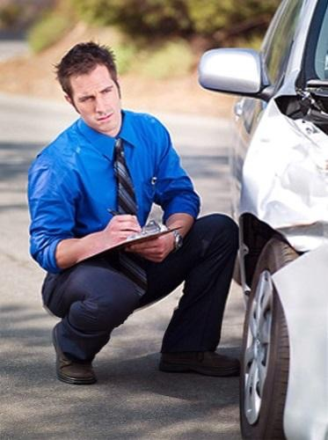
Ideally, the car repair process is simple and the other driver’s insurance fairly handles the repair process. They may simply tell you to get an estimate at the body shop of your choice and the repairs will be authorized and completed. Get the authorization for repair in writing. Get pictures of your car and a copy of the estimate and/or repair bill.
Through the other driver’s insurance, you should also get a rental car while your car is being repaired, although the key word is “should.” If they don’t do so, you can request your own insurance to get a rental car while your car is being fixed.
Will Insurance Handle Everything After an Auto-Accident?
Maybe, is the answer. Your bills may have to be paid initially by your health insurance or your auto insurance “medical payments coverage.” The other driver’s insurance will only make one lump sum settlement payment at the close of the case. In the meantime, your medical bills have to be paid and you are responsible for your bills. Rarely will the at fault insurer pay your bills as they are incurred. If you have a minor injury, you can handle the case on your own, but if you have a significant injury in which you’re disabled or in pain for more than a couple months, you’ll be outgunned and out-resourced by the insurance company. They have millions and millions of dollars to pay defense attorneys and adjusters and experts and you don’t. The insurance industry’s hard core business goal, is profit. They profit by collecting insurance premiums and then they pay out in claims. Paying claims hurts their profit. Insurance companies’ primary purpose is to collect money, invest it and keep the profit. Their secondary purpose is to pay no money or as little money as possible on claims.
So, the playing field is not level. Insurers have unlimited resources (time and money) and you do not. To have a fair chance, you need a capable, aggressive and trustworthy attorney on your side.

Types of Vehicles Typically Involved in Commercial Vehicle Accidents
Commercial vehicles are trucks or other transportation mechanisms used for business purposes. Commercial vehicles include trucks of all types, tractor-trailers, pickups, delivery trucks, taxis, and buses. A commercial vehicle could be a UPS or FedEx truck or a food delivery car.
Many collisions are caused by taxis, and, now Uber, Lyft and other ride sharing transportation companies. Any vehicle, truck or car used for business is a “commercial” vehicle. Businesses exist to make money. Companies exist to make money, so businesses are responsible for damages caused by their vehicles used in the course of business.
Delivery vehicles have a higher collision frequency, in part because they must make their deliveries quickly. Drivers can be distracted or drive too fast. Jimmy Johns promises “freaky fast” delivery. That guarantee of fast is certain to cause speeding, crashes and injury.
Our office is in the Chicago Loop. At least half of the vehicles on the road are taxis. Taxis are always shooting in and out of traffic lanes, making overly aggressive turns, and pressing up on pedestrian crosswalks. They are paid to go fast. When they cause injury, they must pay. We often see clients injured by taxis, delivery trucks and tractor-trailers.
Are Commercial Vehicles Subject to Different Regulations and Laws than Personal Vehicles?
Specific laws and regulations apply to commercial vehicles. For example, tractor-trailers that haul loads on highways are subject to federal and state laws regarding truck use and operation.
Owners have to ensure that safe maintenance schedules are followed. Loading must be proper and critical systems like steering and brakes must be regularly inspected. Drivers, according to federal state law, must inspect their vehicles before and after each trip. Drivers are strictly limited in the number of hours they can be on the road.
Loads placed into trailers cannot be too heavy. That’s why you see roadside weigh stations along the interstate. Loads must be secured and balanced so as not to allow for load shifting. There are regulations and laws that affect commercial vehicles and rightly so. Commercial vehicles used for business purposes pose a very significant risk to other drivers, bicyclists and pedestrians who use the roadways.

Common Causes Of Commercial Vehicle Accidents
We live in an age of distraction. Even though the message “don’t text and drive” is everywhere, people still text while they’re driving. People use other phone functions while driving. Any phone use is a distraction from the primary task of safe driving.
Drivers often talk on the phone while driving. The human brain cannot fully focus on two things at once. A motorized vehicle presents a risk of harm to everyone on the road and it commands a driver’s full attention.
Carelessness is a cause of collisions. Carelessness includes driving too fast, following too closely, making sudden lane changes, disobeying traffic signals, or just simply not paying proper attention.
When a driver of a commercial vehicle is careless, a collision can occur. In fact, if you think about it, the two biggest factors in vehicle collisions are improper speed and improper lookout.
Any one of us can potentially cause these things, but a commercial vehicle, because of its size, can cause exponentially greater damage than a car. If a truck is going too fast, it’s more likely to rear-end somebody, run through a light, go through a stop sign and cause an injury. If a driver is not keeping proper look out, there are hazards that they may not see properly and it increases the likelihood of a collision. Many business policies pressure drivers to drive unsafely and that encourages lack of a proper lookout.
Think about the Jimmy John’s example - their deliveries are “freaky fast.” It concerns me when I hear the radio commercials bragging that they’re “freaky fast.” When you see drivers with the Jimmy John’s signs on top, they’re pressured to get the food to the customer now! The problem is, someone’s hunger may be satisfied, but possibly at the expense of someone being injured.
Domino’s Pizza used to guarantee 30-minute delivery time. To me, that’s ridiculous because it encourages drivers to be drive unsafely and cause injury. In fact, the company ended the policy after several major collisions by Domino’s drivers caused serious injuries. When a commercial vehicle causes a collision, the owner and the driver of the vehicle are responsible. Perhaps other companies involved with that vehicle can be responsible. For example, if a company has a fleet of trucks and they hire a maintenance company to do regular inspections, but the brakes weren’t inspected on a timely basis and the brakes fail, the maintenance company may be responsible. So it is important that a full investigation be conducted of a claim involving a commercial vehicle.
Can Companies Avoid Liability?
Certainly corporations and insurance companies are masterful at protecting themselves from liability. It is unfortunately true that companies often seek to avoid liability. Corporations can be successful at arranging their legal relationships in an attempt to avoid liability. However, a skilled attorney can work through those legal defenses and help you. Another way of avoiding liability is when insurance companies place “fine print” in their policies. Such fine print includes limitations, exclusions and deadlines in an attempt to not pay under certain conditions.
Having an effective attorney working through insurance company nonsense is sometimes the difference between a successful claim or failure. In addition to filing suit against owners and maintenance companies, you must also seek recovery against the driver. Corporate insurance policies typically cover both the owner and the driver.
What Happens if a Driver of a Commercial Vehicle is a Private or Independent Contractor?
A company and their drivers can set up all sorts of agreements between themselves, but the law may invalidate those private agreements. We are a nation of laws. Companies should not be able to avoid liability based on technicalities or their efforts to blame others. We seek to hold whomever is responsible for a collision, liable. For example, a company can call a driver an “independent contractor” and have the driver sign an agreement saying that. However, if we find that the driver is an employee under the law, we call the driver an agent of the company and make the company responsible for the actions of its agent, the driver. The law is fairly complex on this issue and it often requires research and investigation, but we enjoy investigating and proving these types of cases.

Difference Between Commercial and Passenger Vehicle Accidents
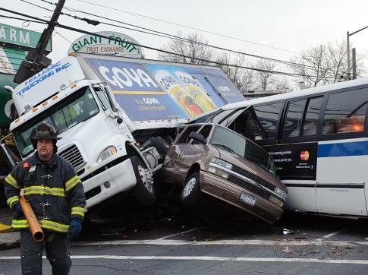
Business vehicles typically cause more severe injuries because they’re bigger and heavier than passenger cars. If you think of physics: mass and speed - you know this is true. Because trucks are usually larger and heavier than cars, the damage is usually greater and the injury to the person inside is almost always worse. Would you rather be rear-ended by a Toyota Prius or a tractor-trailer?
Typical Injuries Sustained in Commercial Vehicle Accidents
We have seen terrible consequences from truck collisions - from paralysis to brain injuries to severe neck and back damage and even fatal injuries. We’ve seen horrific crush injuries in which cars go under tractor-trailers. We have seen injuries requiring hospitalization and surgeries, and we have seen a coma that resulted in death.
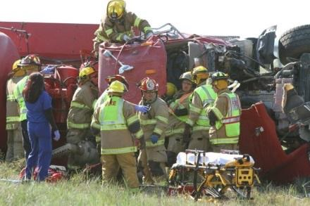
We have seen injuries to the extremities, the legs and arms and all their parts - knees, shoulders and hands. Typically, the injuries sustained in a crash with a commercial vehicle are significant, alter people’s lives and require extensive recovery time and treatment.
Steps to Take When Involved in a Commercial Vehicle Accident
Get treatment. Go to the emergency room if in severe or disabling pain, so treaters can rule out something imminently harmful. Next you may choose to go to your family doctor who will likely refer you to a specialist. If you’re hurt, you need medical treatment.
The second thing to do is make sure you gather any and all evidence. Record information about the accident, photos of the scene and vehicles, photos of visible injuries, and information about witnesses, your medical treatment and anything else that you think may be relevant. Gather it together and have a capable attorney sort through it.
Third, get a free consultation with an attorney who knows what they’re doing. You should be comfortable with your attorney and feel that you can tell them anything or ask them anything related to your claim.

The Challenges People Face in Commercial Vehicle Accident Cases
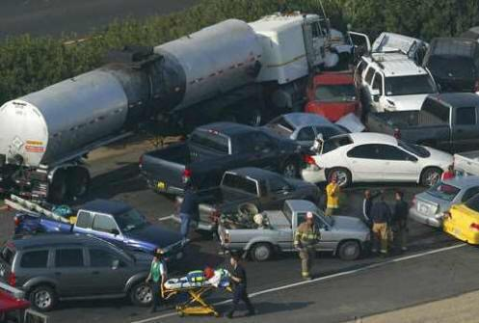
There are many challenges in these cases, so allow me to discuss it in two parts: the physical aspect of your injuries and the financial aspect.
The physical aspect is dealing with your pain and limitations. Our bodies are meant to do wonderful things - to move around, to allow us to work, play and hug our loved ones. When our bodies are subject to trauma, it can take a long time to recover. It can be weeks, months or even years before you return to normal.
Dealing with pain, at least at the outset of the case, is a major challenge. When you have a significant injury and you deal with pain at home or work, you’re dealing with it 24/7. When the pain is severe enough to the point that you can’t sleep, the problem is compounded. People have a tremendous problem with fatigue when recovering. When you’re severely injured and disabled, meaning you can’t take care of yourself or your family the way you did before, it will be frustrating and possibly disheartening. Dealing with disability is difficult on all levels. Hopefully you’re in a situation in which you will improve over time and return to your normal work and home status. A positive attitude is a must.
Another big challenge is having reduced or no income and mounting expenses. We need money to pay our bills. When you can’t pay your bills and maintain your mortgage, your utilities, food and other expenses, that is a big challenge. We can assist in finding disability insurance you may have available through your own policies or through work. There may be loan help available on a limited basis. We don’t necessarily advocate for that, but we’ll assist in the process of getting you at least some kind of short-term compensation.
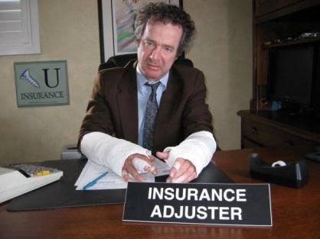
The time that is involved with an injury claim can also be a challenge. Cases can take months, or they can take over a year. We know you just want the case over with and to be fairly compensated. When you’re dealing with anything that is unknown, it can be fearful. For most people dealing with the insurance industry and the legal system, it’s an unknown, so that fear can creep in. We are here to help you alleviate your fears.
Part of the process oftentimes involves the insurance company denying or questioning you. That is frustrating. It is always frustrating when people deny something that we know to be true.
We are here to listen to you and counsel you through the process. If your case must be filed in court, you will have to give a statement known as a deposition. The defense attorney for the insurance company can be very offensive and very aggressive, but we will prepare you, be present with you and protect you. We work to make the process as effective as painless as possible.

What Happens if my Commercial Vehicle Accident Claim is Denied?
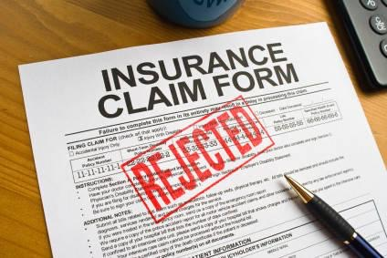
Get a great attorney. You may want to talk to two or three attorneys to see how you feel about them. They should offer a no-obligation free consultation. You want to find someone who is capable with a proven track record and feel that they understand you. You should feel comfortable and have a connection with the attorney. And, I recommend not signing any papers or giving any statements until you have had a legal consultation.
Compensation Recovered from A Commercial Vehicle Claim
You can seek to recover all of your “damages,” which is a legal term for what you experienced because of the incident. The two big categories are economic and non-economic damages. Economic losses are financial, like medical bills, income loss, medication, devices such as crutches or wheelchairs.
Non-economic losses are those things you feel and experience due to your injuries: the pain, suffering, disability, disfigurement. Top-notch attorneys will work to get you compensation for all of your losses.
Importance of an Attorney in Handling a Commercial Vehicle Claim
Insurance companies and the businesses they insure are experienced in the claims process and litigation. They have vast resources and they are committed to paying as little as possible. You need someone to level the playing field - you need an advocate on your side.
Our mission here is maximum recovery in the minimum period of time. Our strategy is to plan, prepare and persist. Each of those ingredients is necessary for a successful result. For your case, we will plan the case goals with you, we will prepare it in a proper way, and we will persist, even if things get difficult.
You can handle your case on your own but in my experience, 9 out of 10 times you won’t be successful. You will have trouble not because you’re not smart, tough or committed, it’s because you don’t know the rules, you don’t have the resources and you don’t have the wherewithal to succeed in these things. The insurance procedures and legal systems are complicated. In some ways the claims process is intentionally designed to frustrate you. You need a strong advocate in your corner.

Uninsured / Under-Insured / Hit and Run Motorist Claims in Illinois
Statistics show that one in seven drivers (13%) are uninsured based on studies by governmental and private research groups.
In my experience, most drivers are underinsured, which means they don’t have enough insurance to cover injuries they may cause. I see it every week in my law practice. Hopefully, you have hefty underinsured motorist coverage that is greater than your damages. At a minimum, it should be $100,000 or more, even $250,000 or $1 million.
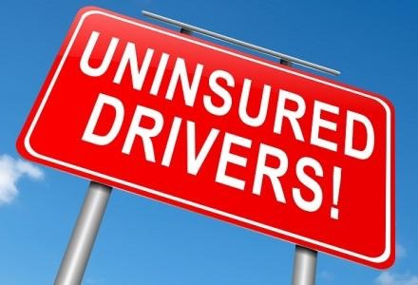
The thing about underinsured motorist coverage is we really don’t know if it is needed until we learn about the other driver’s liability limits. In my extensive experience, the vast majority of people have policies of only $20,000-$100,000 which is not enough insurance in cases of a serious injury. So, if you have a serious injury, and the other driver has less than $100,000 in liability coverage - they are underinsured.
With regard to your own uninsured and underinsured motorist coverage, get big coverage. I encourage you to call your agent today to increase your limits. The increase is typically affordable. To double or triple your coverage is only a nominal increase. If your premium is $1,000, to double your underinsured motorist coverage doesn’t mean a premium increase to $2,000, it may be an increase of $100 or so.
It’s a huge consumer disservice that insurance companies don’t inform customers about the need for additional coverage and the low cost. My belief is that insurers do not want to have big exposure on high limits because the premium increases do not justify the exposure. They don’t tell people, “Well, for 25 bucks more, we’ll double or triple your coverage,” because it’s not in their best interests. Their risk doubles or triples, but their income only increase a small amount. I’ve pushed for legislation to require insurer disclosure of the modest premium costs for massive coverage increases. It is an important consumer fairness issue.

What if I’m Involved in an Auto Accident with an Uninsured Motorist?
First, get a police report. Next, get immediate medical attention.
You will be well served by getting a brief and free -no obligation consultation with a competent attorney. Then notify the insurers yourself or through your attorney.
It is important to record and document all of your experiences: keep copies of bills and records, photograph
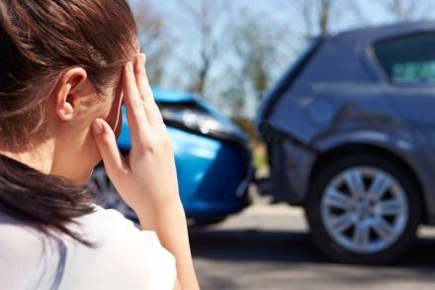
the scene, the vehicle and your injuries. Write “confidential attorney client” notes about how the injury affects you. Write out what pain you have including location, description, intensity and duration. Note how you are limited in daily activities.
What we can do is to make sure the traffic citation that was issued against the uninsured driver is enforced. We go to court with you or for you to make sure that the prosecutor and judge know that this driver is uninsured and that you were injured. This is important so that the negligent uninsured driver does not get off without some consequence.
We also confirm the uninsured motorist’s status with the Secretary of State. After the State confirms that the other driver is uninsured, they will move to revoke the license of that driver until payments are made. We also investigate any assets or income which the other driver may have.
We file a certified notice of claim and a demand for arbitration with your uninsured or underinsured motorist carrier. This is to protect your rights with regard to deadlines. Your auto insurance policy has a limitation period for filing claims and making the arbitration demand.
You are hopefully getting the treatment you need and documenting your injuries. Then, after you are recovered, we complete the process of compiling evidence of the incident and all of your damages. We consult with you to ensure we have complete information and that we have an agreed goal.
We prepare and send a settlement demand package. Negotiations with your insurer begin and the claim will either settle or we will go to an arbitration, where we will pursue an award in your favor.
You want to at least notify your insurance agent of the claim, but I do not recommend giving a statement nor signing a document without having legal representation to handle the process. It is true that you can simply notify your insurer of the collision with another driver who had no insurance or had low policy limits. Then speak to an attorney who can give you an initial free consultation on your rights and the process.
It is important to understand the difference between notifying your insurer of an incident versus filing a claim; The way insurance policies are written and the way insurance companies operate, it is critical to notify your insurer promptly of an incident. This notice is important, so they cannot later argue you did not provide notice and thus deny coverage.
You then make a claim only when you have to - if the other driver does not have insurance.
If you are at fault in the accident, the other motorist will make a claim on your insurance company and they will handle it. Your insurance company will likely call you to ask you about the facts of the incident. Your cooperation is required.

Does Illinois Require Uninsured Motorist Coverage?
Yes. The Illinois Insurance Code requires uninsured and underinsured motorist coverage to be provided in every auto liability policy. This means that every car insurance liability policy must have must also have uninsured and underinsured motorist coverage.
Fortunately, the courts are inclined to rule in favor of consumers (as opposed to insurers) in the area of uninsured and underinsured motorist coverage.
It is one of the few areas where the public has some protection from the courts against insurance companies.
What Does Uninsured Motorist Coverage Actually Cover?
Uninsured motorist coverage covers all your injury related losses. Your losses or “damages” include economic losses, such as medical expenses and wage loss, and
non-economic losses such as pain and suffering, disability and disfigurement.
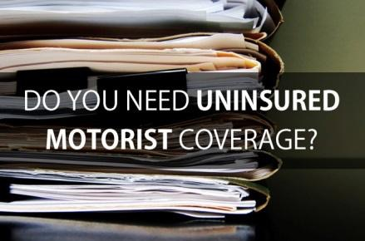
Uninsured and underinsured motorist coverage is automatically included in your policy. Insist on getting a declaration of coverages that shows the dollar amounts of each coverage. The declaration is a page that will show your coverages and the limits of your coverage. The limits for your uninsured and underinsured motorist coverage must be equal to your liability limits. I strongly recommend that you have at least $100,000 in liability, uninsured, and underinsured motorist coverages. Ideally you carry $500,000 or more. My friend just increased his limits from $100,000 to $500,000 for just $14 a month!

Is it Advisable to Sue an Uninsured Person?
In certain circumstances, you may sue the uninsured person, but such a suit is usually not worthwhile. In the vast majority of cases, if a person drives without car insurance, they don’t have assets (like a house or savings or investments), and they don’t have significant income. Even if you could sue the uninsured motorist, they usually file bankruptcy, which means you are prevented from pursuing the lawsuit. In some cases, we have to sue the uninsured driver to protect the rights of your own insurance company in the event that we make an uninsured motorist claim.
How Do You Advise Clients Regarding a Lawsuit Against an Uninsured Motorist?
Most of us are taught from an early age to be responsible for ourselves and that if we break something, we have to fix it. Most of us conduct ourselves according to our own moral or ethical values.
If you are injured due to someone who is irresponsible, (an uninsured motorist), it is frustrating. It is natural to be angry about someone who fails to have insurance and then causes injury. I hear it. I get it. It is wrong and unfair and irresponsible. However, what is your next step? An uninsured motorist claim is your best option.
Life has risk and we have few guarantees. However, we can protect ourselves against some risk. You did that with your insurance coverage. That is the beauty of having uninsured or underinsured motorist protection. You can take steps to reduce the risks that are out there on the roadways.
What we do as lawyers for injury victims, is work within the insurance and legal system, to get some form of justice for you. That justice may come about by monitoring traffic court proceedings to get fines and penalties against the other driver. We also work with state authorities in getting the uninsured motorist’s license revoked until they make some form of restitution.
That is my approach when representing my clients that have been injured by an uninsured motorist. It allows you to have some measure of peace of mind that something will be done to the at fault uninsured driver.

Common Misconceptions Regarding Uninsured Motorists
One common misconception is that if you are injured by an uninsured motorist, you are out of luck. You do have a source of recovery, however, from uninsured motorist coverage.
Another misconception is that whether or not the other guy had insurance, the other driver must pay. Unfortunately, it’s rare to be able to get someone without insurance to pay. Reasonable and responsible people have insurance. When somebody drives without insurance, they’re not reasonable nor responsible, and there is usually just no way to get them to pay because they have nothing to pay with. Or they file bankruptcy to discharge their obligation.
There is another common misconception that I want to clear up. Many people are afraid to make a claim against their own insurance, because they think their rates will go up or they’ll be dropped by their insurer.
However, in Illinois, the law prohibits insurers from increasing insurance premiums or dropping you if the accident is not your fault.
Of course, the legislature has put these laws in place because insurance companies are inclined to drop people who make a lot of claims or if they’re in a lot of accidents. You paid for the insurance coverage and you need them now. Your insurer must pay you what they promised and what you purchased and they cannot increase your rates or drop you if you are not at fault.
Typical Outcomes of Uninsured Motorist Claims
We typically get excellent outcomes for our clients. Our guarantee is for very aggressive, committed advocacy on your part. No honest attorney can guarantee a particular result. Much of my career has been built on being an attorney for people in uninsured and underinsured motorist cases.
I’ve handled hundreds of these cases for clients. I am also an arbitrator who hears and rules on uninsured motorist cases. An arbitrator is like a judge who hears the facts and listens to witnesses and attorneys on both sides. After the case is presented, an arbitrator makes an award. My experience as an arbitrator helps me in presenting cases as an attorney at arbitration. I typically get a good result for my clients.
I have also made law in the Illinois Appellate Court regarding underinsured motorist cases. One case involved a client who was on his bike and seriously injured by an underinsured motorist. His company (American Family) denied there was coverage. So, we went to the trial court and then the appellate court. We won in both courts. The insurer appealed to the supreme court but the supreme court refused to reconsider the rulings by the trial and appellate courts. So, we made law and we found coverage. The case was worth nearly half a million dollars. This was all after the insurance company denied coverage.
I’m also involved in getting the laws changed or amended so that they are more favorable to insurance consumers.
I’ve had three different pieces of legislation approved by the legislature and signed into law.
One has to do with arbitration awards for uninsured and underinsured motorist cases. Insurance companies want the right to reject those awards and make you go to the court. I’ve been successful drafting amendments that were adopted into law that governs uninsured and underinsured motorist arbitration awards. If the award is under a certain amount, it is binding and cannot be rejected by the insurance company. I also drafted and supported the law that provides for penalties for improper insurance company delay and denial. We aggressively and fairly pursue a settlement or an arbitration award on every case and I would like the opportunity to help you with yours.

How are Hit and Run Accidents Classified in The State of Illinois?
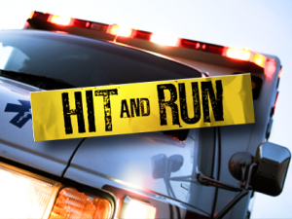
A hit and run accident happens when a driver causes a collision and flees the scene, thus the terms “hit” and “run.” Whenever someone causes an accident then leaves without identifying themselves, that’s a hit and run.
Another type of incident that is classified as “hit and run” is when a vehicle part (e.g. a truck tire tread) from an unidentified vehicle comes off and causes an accident. This does not happen often but sometimes a tire tread or other vehicle part will go flying off a vehicle and cause damage. Because the drivers often don’t know that happened, they continue driving, so they’re unidentified, and that makes them a hit and run driver.
Common Misconceptions About Recovering Compensation After a Hit and Run or Uninsured Motorist Accident
The biggest misconception is that you are out of luck if you are injured in a hit and run accident - but that’s not true if have uninsured motorist coverage. If you’ve been injured by a hit and run driver, you’ll have a remedy with uninsured motorist coverage.
If you’ve been involved in a hit and run accident and you’re injured, first, get treatment. Whether you go to the emergency room, an urgent care clinic or your family doctor, get treatment. Safety first. If you’re hurt, you have to get treatment.
If you’re hurt and you don’t see a doctor, the insurance company will say you’re not hurt and not entitled to payment. They’ll argue that in front of an arbitrator or judge or a jury, and many times, they win.
So, get the care that you need for your injuries, then collect all information about the incident, such as photographs, documents and the incident report. Your insurance company should be notified on a timely basis. If you do not notify them, you can lose your rights.
If you get an attorney, the attorney will pursue these items of recovery for you. However, you have many items that
the attorney can’t get without you. So use a file folder, put everything in there and give the contents to your attorney. If your claim is of any significance, whether or not you get an attorney, I would highly recommend speaking to one. There should be a no-obligation free consultation available, so you don’t have to pay anyone, but take an hour out of your week and become more informed. Even if you decide not to hire an attorney - you have received free advice! And, if you handle the case on your own and it gets to be too much for you to handle, you know where you can go for legal representation.

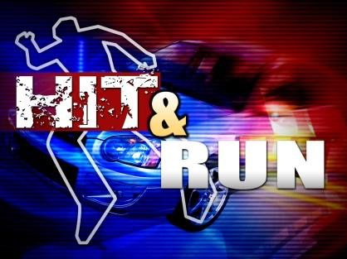
Responsibility for A Hit and Run Accident in Illinois

Unfortunately, in a true hit and run accident, if the driver or owner of other vehicle is never identified, no individual is held responsible. It can be frustrating, but in terms of doing something effective, you make an uninsured motorist claim. Your insurance policy is a contract and it obligates your insurance company to pay you for your damages caused by the hit and run driver. You purchased this valuable protection, and you are entitled to the benefits if needed.
The Importance of Witnesses in Hit and Run Cases
Witnesses to a collision are important. Witnesses to a hit and run collision are even more important because we don’t have the other driver to question about what happened.
The level of witness importance depends on the facts of the case. If you are rear-ended by a hit and run driver, other witnesses are not that important. However, if you lose consciousness and cannot testify about the collision, then you need other witnesses.
If you’re stopped and you’re hit from behind, the other driver is at fault. But if it’s a collision in an intersection, and you’re saying the other driver ran a light, it is very helpful to have a witness confirm that. Likewise, if you were knocked off the road by the hit and run driver, it’s beneficial to have witnesses to confirm what the other driver did.
Witnesses are important but they are not always essential. There are other forms of evidence, like physical damage. Damage to the rear of your car will suggest that you were rear-ended. Tire tracks on the roadway can also be evidence to suggest how an incident happened. All facts are potentially used as evidence and can be used in your favor to prove your case.
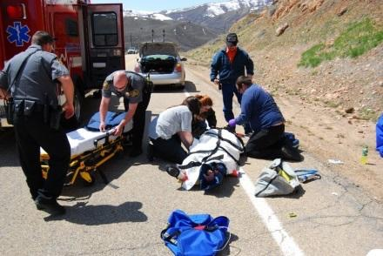
One of the definitions of “uninsured motorist” is hit and run driver. So when you’re injured by a hit and run driver, the driver is considered “uninsured,” and your uninsured motorist coverage applies.
Your insurance premium rate should not be affected if you’re not at fault in a hit and run collision. Illinois law prohibits insurers from raising your rates if you’re involved in a collision and you are not at fault.
We’ve often seen the at fault driver claim to not have insurance, but after we start applying pressure to them by way of a written notice, certified mailings and phone calls, if they do have insurance, they’ll eventually tell us. If they don’t voluntarily do so, we’ll file suit and get them to testify under oath as to their insurance status, but typically, in the early stages of the process, people will eventually tell us their insurance information.

Importance of Retaining an Attorney for a Hit and Run Claim
You need an attorney because your insurance company is a powerful and experienced corporation. Insurers are experienced and skilled experts at delaying claims.
They are knowledgeable on legal rules and procedures. They have an army of insurance adjusters, claims personnel and lawyers who can delay or deny you from getting fair compensation.
An experienced and capable attorney levels the playing field for you. He or she knows the rules, procedures, techniques and strategies that will help you get a maximum recovery in the minimum time.
When you’re badly hurt, you have all sorts of stuff going on - you are in pain, you cannot get around, you’re getting medical treatment, you’re on medication, you’re out of your routine, you cannot work, you can’t do house work, you can’t exercise, you can’t cook or clean, you can’t do recreational activities and you can’t do the simple things that make life worthwhile. It’s really difficult to get your mind and heart around fighting an insurance company under those circumstances.
You likely need an attorney because the insurance company often will make a low ball offer to pay your medical bills and then maybe give you $1,000 or $5,000. The insurance company offer is usually not fair. The offer is usually not what you contracted for when you bought the policy. In our vast experience, after trying to handle cases on their own, people usually do get an attorney.
How Are Attorneys Compensated for Auto-Accident Claims?
You owe us nothing unless we recover for you. Our fee is based entirely on the amount of recovery that we get for you. Thus, we are driven to get you the maximum recovery in the minimum time. Our standard fee is one-third of the recovery. If appropriate, we adjust our rate up or down if the case settles extraordinarily quickly or if early on the case goes through mediation or arbitration. Your case particulars are always subject to discussion and negotiation.

Scott Blumenshine Aggressively Handles Hit And Run / Uninsured / Underinsured Motorist Claims
You want someone who will get the best result and make the experience work for you. You need both information and guidance. When you’ve been injured and you have an insurance claim, it it often an unpleasant experience. We strive to make the best of it for you. We work to keep you informed, taken care of, advised, and well represented. We promise that. We can’t promise a specific result. We can promise our every effort to get you the maximum recovery in the minimum time. Any lawyer who promises you a specific result is not telling the truth. We give you the truth, we give you information and we give you advocacy. We battle for you.
In the area of uninsured and underinsured motorist cases, I have been one of the most active attorneys in this field in Illinois. I’ve represented hundreds of people with uninsured or underinsured motorist cases.
I am an arbitrator (judge) at arbitration hearings. I have written articles on the subject. I have written a book chapter for practicing Illinois attorneys. I am on the Insurance Law Section Council of the Illinois State Bar Association where I served on the Legislative Subcommittee. We review proposed insurance laws that will affect things like uninsured and underinsured motorist cases.
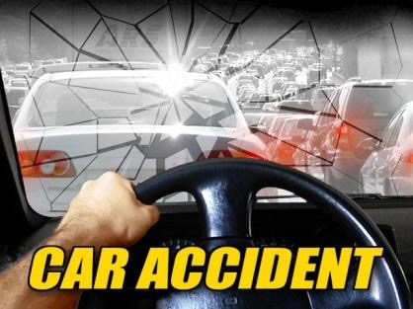
I am now Co-Chair of the Continuing Legal Education Committee of the Insurance Law Section. We arrange for expert attorneys in the area of insurance law to give presentations to other attorneys and inform them on insurance law topics and current strategies to succeed.
I have drafted and supported many pieces of legislation regarding uninsured and underinsured motorist coverage. I have also made some case law (judicial decisions) in the area. It is my mission to help people with uninsured and underinsured motorist cases and I would truly enjoy the opportunity to serve you. Please call me for a free personal case consultation.

